Assignment for Module 7
The assignment for Module 7 provides practice using the Crow’s Foot notation. I have used ER Assistant for this assignment as it allows me to create M-N Relationships,whereas in’
Visual Paradigm,it doesn’t allow to use M-N relationship,as it directly includes an associative
Entity type directly and converts M-N relationship into two 1-M relationships.

Submission
The submission requirements involve evidence that you draw the ERD for each problem and provide an answer to the 4th problem. You have to submit a document containing an ERD drawings. You should use the same table and column names as specified in the assignment. For problem 4, you should indicate the consistency errors in the diagram and type your suggested resolution. You should not put any identifying details about yourself in your submitted document.

- Create an ERD containing the TestOrder and Specimen entity types and a 1-M relationship from Specimen to TestOrder. For each specimen collected, the database should record a unique SpecNo, SpecArea (vaginal, cervical, or endocervical), and SpecCollMethod (thin prep or sure path). A test order contains a TONo (primary key), TOTestName, TOTestType (HPV, CT/GC, CT, or GC), and TOTestResult (positive, negative, equivocal, or failure). A specimen does not have a test order until a delay, from hours to days. If a test order produces a failure, the specimen is given a new test order and tested again until a non-failure result is obtained. A test order is created for exactly one specimen.
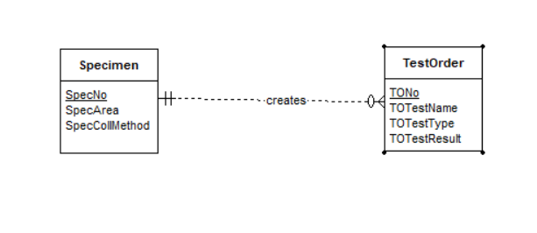

- Augment your ERD from problem 1 with the Supply entity type and an M-N relationship between TestOrder and Supply. Choose a name for the relationship based on your common knowledge of test orders and supplies. A test order can use a collection of supplies (0 or more) and a supply can be used on a collection of test orders (0 or more). The Supply entity type contains SuppNo (primary key), SuppName, SuppLotNo, and SuppQOH.
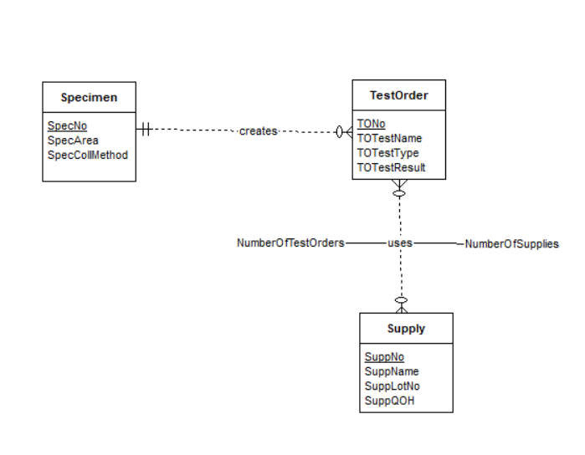

- Use the M-N equivalence rule to transform the M-N relationship in Problem 2. You should choose appropriate names for the new relationships and entity type.
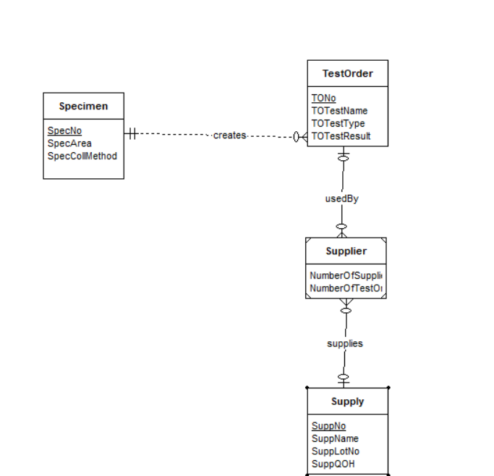

- For each consistency error in Figure 1, you should identify the consistency rule violated and suggest possible resolutions of the error. The ERD has generic names to help will concentrate on finding diagram errors rather than focusing on the meaning of the diagram

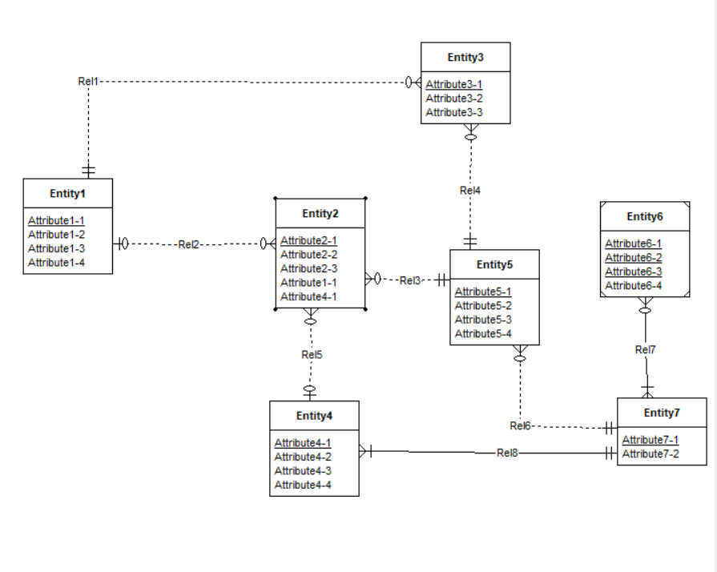
Figure 1: ERD for Problem 4

Violations in the above ERD
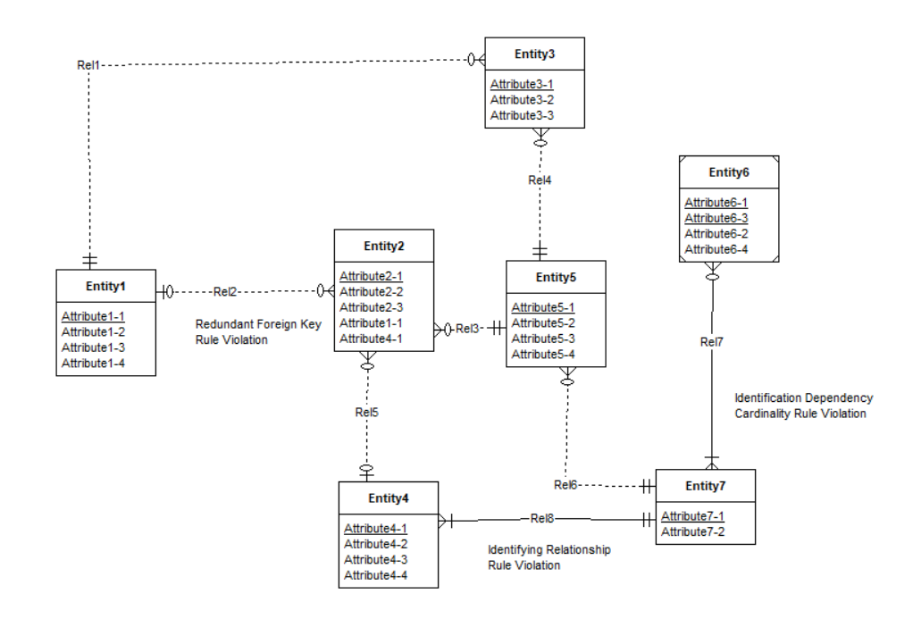

Violations in the above ERD and Resolutions to solve the violations.
- Identifying Relationship rule violation for the relationship Rel8.
Identifying Relationship rule says that atleast one participating entity type should be a weak entity type.So modifying anyone of the entity types Entity4 or Entity7 as a weak entity type will solve the error.
- Redundant Foreign Key Rule violation in Entity2
Reduntant Foreign Keys should not be used while representing an Entity type in ERD. Removing Attribute1-1 and Attribute4-1 in Entity2 will solve the error.
- Identification Dependency cardinality rule violation in Rel7
Idenifying relationship’s minimum and maximum cardinality must be equal to one from a weak entity.Modifying the Cardinality for Rel7 near Entity7 should be made (1,1) ,it will solve the error.

